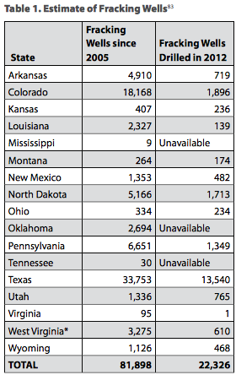 **Wells Fracked by State**

The most basic measure of fracking’s scope is a tally of how many fracking wells have been drilled. In addition, having an accurate count of wells by state offers a basis for estimating specific impacts to water, air and land.

Fracking has occurred in at least 17 states (see Table 1), affecting approximately 82,000 wells. In the eastern U.S., Pennsylvania reports the most fracking wells since 2005, with 6,651 wells tapping into the Marcellus and Utica shales. More than 5,000 fracking wells have been drilled in North Dakota to produce oil from the Bakken formation. Western states with the most fracking include Colorado, New Mexico and Utah.

Absent policies to rein in fracking, fracking is likely to expand in these and other states. Tennessee currently has a handful of wells but more will soon be fracked in the Cumberland Forest. One test well was fracked in Georgia in the past year. Illinois recently adopted new regulations governing fracking, paving the way for the practice there. Oil and gas companies are seeking to expand to states such as California, New York, Maryland and North Carolina where there has been no such activity to date. In New York, as many as 60,000 wells could be drilled.

Data and text from environmentamerica.org

1. What percent of wells from 2005 were still open in 2012? (Choose 5 states)
2. On your graph paper, create a **double bar graph** for the states you chose above that shows the change in open fracking wells. Be sure to use 2 different colors and label your axes.

1. Do you think this data supports an argument FOR fracking or AGAINST fracking? Why?

____________________________________________________________________________________________________________________________________________________________________________________________________________________________________________________________________________________________________________________________________________________________________________________________________________________________________________________________________________________________________________________________________________________________________________________________________________

1. How does your graph relate to your percents?

____________________________________________________________________________________________________________________________________________________________________________________________________________________________________________________________________________________________________________________________________________________________________________________________________________________________________________________________________________________________________________________________________________________________________________________________________________

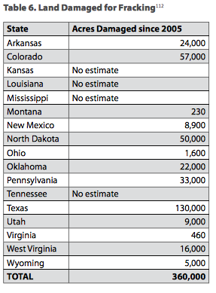

**Acres of Land Damaged**

Nationally, land directly damaged for fracking totals 360,000 acres. (See Table 6.) This estimate includes the amount of land that has been cleared for roads, well sites, pipelines and related infrastructure in each state. However, the total amount of habitat and landscape affected by fracking is much greater. In treasured open spaces, a single well-pad can mar a vista seen from miles around. A study of fracking development in Pennsylvania estimated that forest fragmentation affected more than twice as much land as was directly impacted by development.

Fracking activity in Colorado damaged 57,000 acres, equal to one-third of the acreage in the state’s park system. In Pennsylvania, the amount of land directly affected by fracking-related development since 2005 is equal to all the farmland protected since 1999 through the state’s Growing Greener land preservation program.

1. What percent of the total acres damaged are in Colorado?
2. Which state’s damaged land is about 36% of the total damaged land? How do you know? Show your work.
3. On your graph paper, make a bar graph that shows each state’s damaged land.
4. Do you think this data supports an argument FOR fracking or AGAINST fracking? Why?

____________________________________________________________________________________________________________________________________________________________________________________________________________________________________________________________________________________________________________________________________________________________________________________________________________________________________________________________________________________________________________________________________________________________________________________________________________

1. How does your graph relate to your percents?

____________________________________________________________________________________________________________________________________________________________________________________________________________________________________________________________________________________________________________________________________________________________________________________________________________________________________________________________________________________________________________________________________________________________________________________________________________

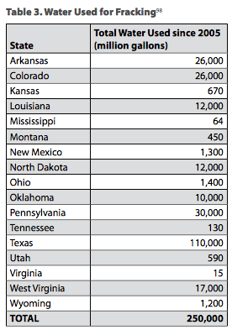

**Water Used**

Since 2005, fracking has used at least 250 billion gallons of water across the nation. Extrapolating from industry-reported figures on water use at more than 36,000 wells since 2011, we estimated total water use for all wells that were fracked from 2005 through mid-2013. (See Table 3.)

The greatest total water consumption occurred in Texas, at the same time the state was struggling with extreme drought. Other states with high water use include Pennsylvania, Arkansas and Colorado. The amount of water used for fracking in Colorado was enough to meet the water needs of nearly 200,000 Denver households for a year.

1. What percent of the total water used are in Colorado?
2. Texas uses 110,000 gallons of water, what percent of the total water used is that? How do you know? Show your work.
3. On your graph paper, make a bar graph that shows each state’s water use.
4. Do you think this data supports an argument FOR fracking or AGAINST fracking? Why?

____________________________________________________________________________________________________________________________________________________________________________________________________________________________________________________________________________________________________________________________________________________________________________________________________________________________________________________________________________________________________________________________________________________________________________________________________________

1. How does your graph relate to your percents?

____________________________________________________________________________________________________________________________________________________________________________________________________________________________________________________________________________________________________________________________________________________________________________________________________________________________________________________________________________________________________________________________________________________________________________________________________________

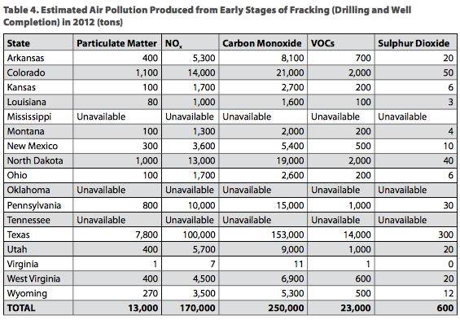

**Air Pollution Created**

Fracking created hundreds of thousands of tons of air pollution in 2012. As shown in Table 4, well-site operations during drilling and well completion generated approximately 450,000 tons of health-threatening air pollution. And that does not even include the significant emissions from ongoing operations, compressors, waste pits and truck traffic to and from drilling sites carrying supplies and personnel.

This air pollution estimate for all wells is based on emissions figures from wells in the Marcellus Shale. Different drilling targets and practices may lead to different results. Additional research and improved data availability will help clarify the amount of pollution occurring in different regions.

The 2012 NOx emissions from the early stages of fracking in Colorado were equal to 27 percent of the NOx produced by power plants in the state, assuming fracking well emissions rates were similar to those in the Marcellus. In Pennsylvania, fracking produced NOx equal to 7 percent of that emitted in 2011 by electricity generation, a major source of smog-forming emissions.

1. What percent of the air pollution in each category is produced in Colorado?
2. One state contributes at least 50% of the pollution in each category. What state is that? How do you know?
3. Choose one of the categories above and, on your graph paper, create a bar graph that displays the pollutants for each state.
4. Do you think this data supports an argument FOR fracking or AGAINST fracking? Why?

____________________________________________________________________________________________________________________________________________________________________________________________________________________________________________________________________________________________________________________________________________________________________________________________________________________________________________________________________________________________________________________________________________________________________________________________________________

1. How does your graph relate to your percents?

____________________________________________________________________________________________________________________________________________________________________________________________________________________________________________________________________________________________________________________________________________________________________________________________________________________________________________________________________________________________________________________________________________________________________________________________________________